**Installation instructions of Arduino IDE is shown in the following picture:**

1.Open setup package to find **arduino-1.7.8.org-windows.exe.**

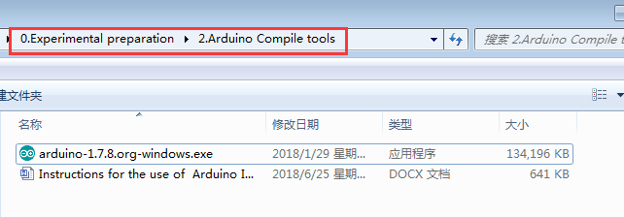

2.Double click to open the installation package **arduino-1.7.8.org-windows.exe.**

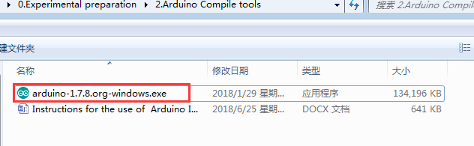

3.Click **I Agree.**

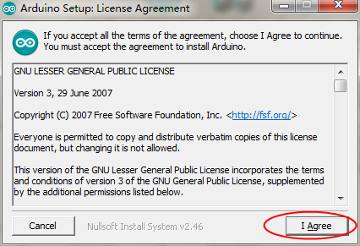

3. According to the default tick installation.

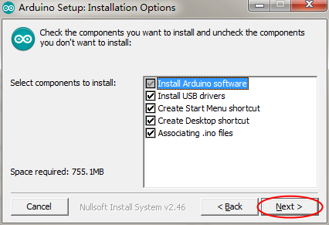

1. Select the installation directory.



5.Wait for the progress bar to complete，and operate as shown in the following figure.

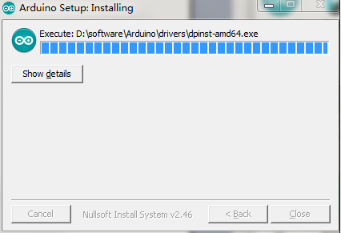

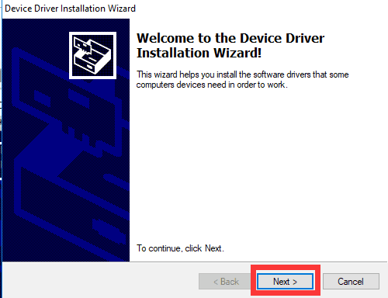

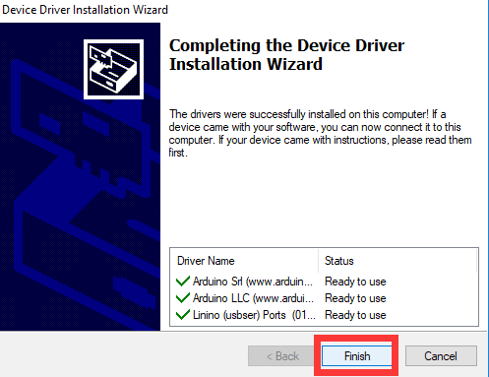

After the steps above, the Arduino IDE is successfully installed.